Chapter 3 Challenges

Colin Fausnaught

1. //Ch3Cha1.java  
  
import java.util.Scanner; //needed for scanner  
  
public class Ch3Cha1  
{  
 public static void main(String args[])  
 {  
 //variables  
 int num;  
   
 //create scanner  
 Scanner keyboard = new Scanner(System.in);  
   
 //prompt  
 System.out.println("Enter a number from 1-10: ");   
 num = keyboard.nextInt();  
   
 //switch  
 switch (num)  
 {  
 case 1:  
 System.out.println("I");  
 break;  
 case 2:  
 System.out.println("II");  
 break;  
 case 3:  
 System.out.println("III");  
 break;  
 case 4:  
 System.out.println("IV");  
 break;  
 case 5:  
 System.out.println("V");  
 break;  
 case 6:  
 System.out.println("VI");  
 break;  
 case 7:  
 System.out.println("VII");  
 break;  
 case 8:  
 System.out.println("VIII");  
 break;  
 case 9:  
 System.out.println("IX");  
 break;  
 case 10:  
 System.out.println("X");  
 break;  
 default:  
 System.out.println("Error");  
 }  
   
 }  
   
}

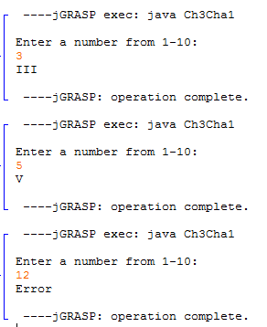

2. //Ch3Cha2.java  
  
import java.util.Scanner; //needed for scanner  
  
public class Ch3Cha2  
{  
 public static void main(String args[])  
 {  
 //variables  
 int day, month,year;  
   
 //create scanner  
 Scanner keyboard = new Scanner(System.in);  
   
 //prompt  
 System.out.println("Enter day of month: ");  
 day = keyboard.nextInt();  
 System.out.println("Enter month in numerals: ");  
 month = keyboard.nextInt();  
 System.out.println("Enter last two digits of year: ");  
 year = keyboard.nextInt();  
   
 //decision statement  
 if((day \* month) == year)  
 System.out.println("Date is magic!");  
 else  
 System.out.println("Date is not magic.");  
   
 }  
}

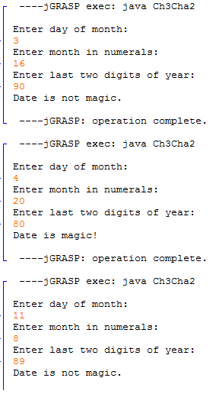

3. //Ch3Cha3.java  
  
import java.util.Scanner; //needed for scanner  
  
public class Ch3Cha3  
{  
 public static void main(String args[])  
 {  
 //variables  
 double weight, height, BMI;  
   
 //create scanner  
 Scanner keyboard = new Scanner(System.in);  
   
 //prompt  
 System.out.println("Enter weight: ");  
 weight = keyboard.nextDouble();  
 System.out.println("Enter height: ");  
 height = keyboard.nextDouble();  
   
 //calculate   
 BMI = weight \* 703 / (height \* height);  
   
 if(BMI >= 18.5 && BMI <= 25)  
 System.out.println("BMI is " + BMI + ". Optimal BMI.");  
 else if (BMI > 25)  
 System.out.println("BMI is " + BMI + ". Overweight.");  
 else  
 System.out.println("BMI is " + BMI + ". Underweight.");  
   
 }  
 }

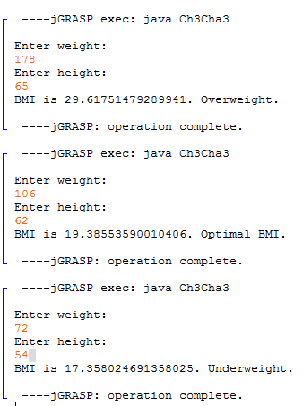

7. //Ch3Cha7.java  
  
import java.util.Scanner; //needed for scanner  
  
public class Ch3Cha7  
{  
 public static void main(String args[])  
 {  
 //variable  
 String name1, name2, name3;  
   
 //create scanner  
 Scanner keyboard = new Scanner(System.in);  
   
 //prompt  
 System.out.println("Enter name 1: ");  
 name1 = keyboard.nextLine();  
 System.out.println("Enter name 2: ");  
 name2 = keyboard.nextLine();  
 System.out.println("Enter name 3: ");  
 name3 = keyboard.nextLine();  
 System.out.println("\n");  
   
 //decision structure  
 if(name1.compareTo(name2) < 0 && name1.compareTo(name3) < 0)  
 {  
 if(name2.compareToIgnoreCase(name3) < 0)  
 System.out.println(name1 + "\n" + name2 + "\n" + name3);  
   
 else if(name2.compareToIgnoreCase(name3) > 0)  
 System.out.println(name1 + "\n" + name3 + "\n" + name2);  
   
 else  
 System.out.println(name1 + "\n" + name2 + "\n" + name3);  
 }  
 else if(name1.compareToIgnoreCase(name2) > 0 && name1.compareToIgnoreCase(name3) > 0)  
 {  
 if(name2.compareToIgnoreCase(name3) < 0)   
 System.out.println(name2 + "\n" + name3 + "\n" + name1);  
   
 else if(name2.compareToIgnoreCase(name3) > 0)  
 System.out.println(name3 + "\n" + name2 + "\n" + name1);  
   
 else  
 System.out.println(name2 + "\n" + name3 + "\n" + name1);  
 }  
 else if(name1.compareToIgnoreCase(name2) < 0 && name1.compareToIgnoreCase(name3) > 0)  
 {  
 if(name2.compareToIgnoreCase(name3) < 0)  
 System.out.println(name1 + "\n" + name2 + "\n" + name3);  
   
 else if(name2.compareToIgnoreCase(name3) > 0)  
 System.out.println(name3 + "\n" + name1 + "\n" + name2);  
   
 else  
 System.out.println(name1 + "\n" + name2 + "\n" + name3);  
 }  
 }  
   
}

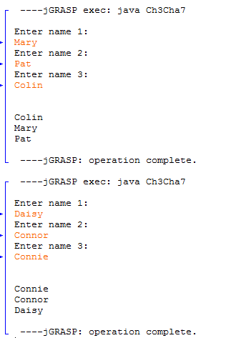

.

9. //Ch3Cha9.java  
  
import java.text.DecimalFormat; //needed for DecimalFormat  
import javax.swing.JOptionPane; //needed for JOptionPane  
  
public class Ch3Cha9  
{  
 public static void main(String args[])  
 {  
 //variables  
 double lbs, miles, rate, mod, end;  
 int getNum;  
 final int SMILES = 500;  
 String input;  
   
 //prompt  
 input = JOptionPane.showInputDialog("Enter weight: ");  
 lbs = Double.parseDouble(input);  
   
 input = JOptionPane.showInputDialog("Enter miles: ");  
 miles = Double.parseDouble(input);  
   
 //decimal format  
 DecimalFormat formatter = new DecimalFormat("##0.00");  
  
 //decide rate  
 if(lbs <= 2)  
 rate = 1.1;  
 else if(lbs > 2 && lbs <= 6)  
 rate = 2.2;  
 else if(lbs > 6 && lbs <= 10)  
 rate = 3.7;  
 else if(lbs > 10)  
 rate = 3.8;  
 else  
 rate = 0;  
   
 //decide the price  
 getNum = (int)miles / SMILES;  
 mod = miles % SMILES;  
 if(mod > 1)  
 getNum += 1;  
   
 //calculate  
 end = getNum \* rate;  
   
 //display  
 JOptionPane.showMessageDialog(null, "The end price is: $" + formatter.format(end) + ".");  
   
 }  
   
}

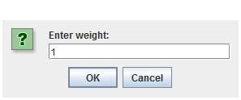

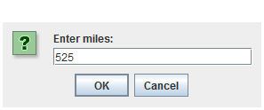

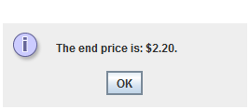

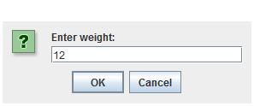

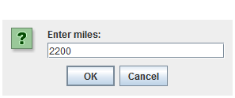

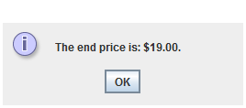

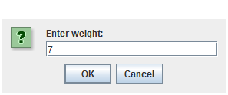

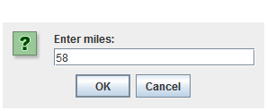

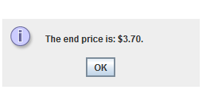

13. //Ch3Cha13.java  
  
import java.text.DecimalFormat; //needed for DecimalFormat  
import java.util.Scanner; //needed for scanner  
  
public class Ch3Cha13  
{  
 public static void main(String args[])  
 {  
 //variables  
 String pack;  
 char packChar;  
 double hours, nHours, total;  
   
 //decimal format  
 DecimalFormat formatter = new DecimalFormat("##,##0.00");  
   
 //create scanner  
 Scanner keyboard = new Scanner(System.in);  
  
 //prompt  
 System.out.println("Enter Package letter: ");   
 pack = keyboard.nextLine();  
 packChar = pack.charAt(0);  
 System.out.println("Enter hours: ");  
 hours = keyboard.nextDouble();  
   
 //decision structure  
 switch(packChar)  
 {  
 case 'a':  
 case 'A':  
 if(hours > 10)  
 {  
 nHours = hours - 10;  
 total = 9.95 +(nHours \* 2);  
 System.out.println("Your total is: $" + formatter.format(total) + ".");  
 }  
 else

{  
 total = 9.95;  
 System.out.println("Your total is: $" + formatter.format(total) + ".");

}  
 break;  
 case 'b':  
 case 'B':  
 if(hours > 20)  
 {  
 nHours = hours - 20;  
 total = 13.95 +(nHours \* 1);  
 System.out.println("Your total is: $" + formatter.format(total) + ".");  
 }  
 else

{  
 total = 13.95;  
 System.out.println("Your total is: $" + formatter.format(total) + ".");

}  
 break;  
 case 'c':  
 case 'C':  
 total = 19.95;  
 System.out.println("Your total is: $" + formatter.format(total) + ".");   
 break;  
 default:  
 System.out.println("Error");  
 }  
   
 }  
   
}

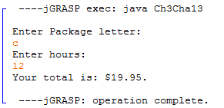

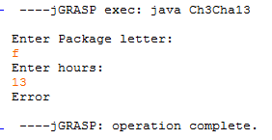

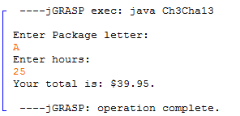

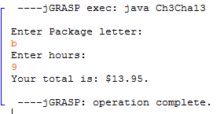

14. //Ch3Cha14.java  
  
import java.text.DecimalFormat; //needed for DecimalFormat  
import java.util.Scanner; //needed for scanner  
  
public class Ch3Cha14  
{  
 public static void main(String args[])  
 {  
 //variables  
 String pack;  
 char packChar;  
 double hours, nHours, total, bHours, bTotal;  
   
 //decimal format  
 DecimalFormat formatter = new DecimalFormat("##,##0.00");  
   
 //create scanner  
 Scanner keyboard = new Scanner(System.in);  
  
 //prompt  
 System.out.println("Enter Package letter: ");   
 pack = keyboard.nextLine();  
 packChar = pack.charAt(0);  
 System.out.println("Enter hours: ");  
 hours = keyboard.nextDouble();  
   
 //decision structure  
 switch(packChar)  
 {  
 case 'a':  
 case 'A':  
 if(hours > 10)  
 {  
 nHours = hours - 10;  
 total = 9.95 +(nHours \* 2);  
 System.out.println("Your total is: $" + formatter.format(total) + ".");  
 if(total > 18.95)  
 {   
 bHours = hours - 20;  
 bTotal = 13.95 +(bHours \* 1);  
 System.out.println("You could have saved $" + formatter.format(total - bTotal) +   
 " if you used package B.");  
 if(total > 19.95)  
 System.out.println("You could have saved $" + formatter.format(total - 19.95) +   
 " if you used package C.");  
 }  
   
 }  
 else  
 {  
 total = 9.95;  
 System.out.println("Your total is: $" + formatter.format(total) + ".");  
 }  
 break;  
 case 'b':  
 case 'B':  
 if(hours > 20)  
 {  
 nHours = hours - 20;  
 total = 13.95 +(nHours \* 1);  
 System.out.println("Your total is: $" + formatter.format(total) + ".");  
 if(total > 19.95)  
 {  
 System.out.println("You could have saved $" + formatter.format(total - 19.95) +   
 " if you used package C.");  
 }  
 }  
 else  
 {  
 total = 13.95;  
 System.out.println("Your total is: $" + formatter.format(total) + ".");  
 }  
 break;  
 case 'c':  
 case 'C':  
 total = 19.95;  
 System.out.println("Your total is: $" + formatter.format(total) + ".");   
 break;  
 default:  
 System.out.println("Error");  
 }  
   
 }  
   
}

